UCI Opportunity data supplemental material:

To be utilized with the ‘All_features_and_labels.mat’ file. The following table gives the nested cross validation sets.

Table 1: Showing distribution of test sequences across nested sets on UCI Opportunity data [1]. Set 1 contain 9 fully labeled sub-sequences (row 2), set 2 contains 5 (row 3), set 3 also 5 (row 4) and so on.

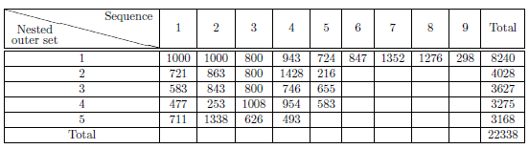

References:

1. R. Chavarriaga, H. Sagha, A. Calatroni, S. Digumarti, G. Trster, J. D. R. Milln, D Roggen. "The Opportunity challenge: A benchmark database for on-body sensor-based activity recognition". Pattern Recognition Letters, 2013.